CGD complex game

**Title:** The first contact.

**Genre:** Sci-fiThriller, survival shooter, somewhat adventure.

**Theme:** space/future.

**Platform and game controls:** console. The game has basic functions of a shooter with using the joysticks to move and look around, left and right sticks to aim and shoot, A/X button to jump etc.

**Narrative: (note: I used dead space as a format)** The story is you play as a guy named dean morrow in earths “United Celestial Navy”. There was a destress call from one of humanities bases on a far distant planet and you and one naval ship are sent to investigate. You find the base heavily damaged with few life signs. While a medic team were sent down the ship is attacked by a colossal alien bio-ship and soon need to evacuate. You spend the game looking for survivors of your ship and fight off these aliens and discover their origin. The first encounter makes it seem they are invulnerable to physical damage but as you discover certain types of these aliens are immune to certain weapon types. (Will elaborate in mechanics)

**Character design:** dean morrow wears some futuristic Armor with a life support pact, helmet etc.

**Level/environment design:** as you’d expect it is set on a large, damaged moon base. The base itself is expansive with different floors and many room to explore. They are areas meant for farming, experiments research etc. Sometimes the games will take place in your ship that got jumped which is expansive itself then the alien ship then eventually an alien space station to destroy it.

**Game mechanics:** the game uses weapons however they are different types: kinetic (like regular bullets) fire, electricity, ice and acid like weapons. The aliens are immune to all but one of these depending on the alien. The aliens are diverse with varying designs these designs are the indicators of what element they are weak against. However, as you progress these change to throw you off. The only indicator to that is brief dialogue. They are boss fights in the game with most having puzzles, example: the puzzle for a boss or final boss in the alien space station is that boss is immune to all weapons. To damage it: there is an icon that varies but it is an icon belonging to one of the weapon types next to the boss’s health bar. They are bio-table things scattered around the boss room each emanating one of the elements, (the kinetic table doesn’t emit anything) there’s also a bio-battery. The goal is to take that battery, take it to one of the element tables to match the icon on the screen, charge the table then pick a weapon that also matches the icon, press a button that appears on the screen (X,B,A whatever) now your weapon is specially charged and able to damage the boss. After a short while the boss will change what element harms it then a new element icon appears. It is rinse and repeat from there.

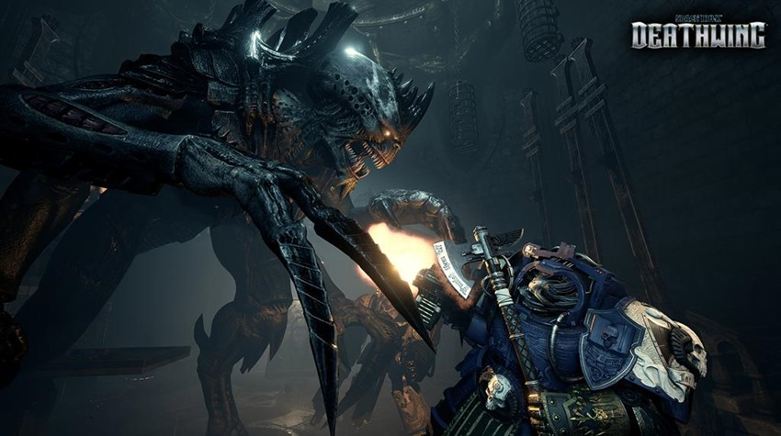The aliens are based on the tyranids from the WH40k deathwing game with both being adaptive. (it lore wise for the tyranids not in the game)

Destiny 2’s master modes have the element enemy thing. (Well, think that’s what it means, I at least got the idea)

(Hard to get a good picture) destiny 2 also has the puzzle I mentioned.

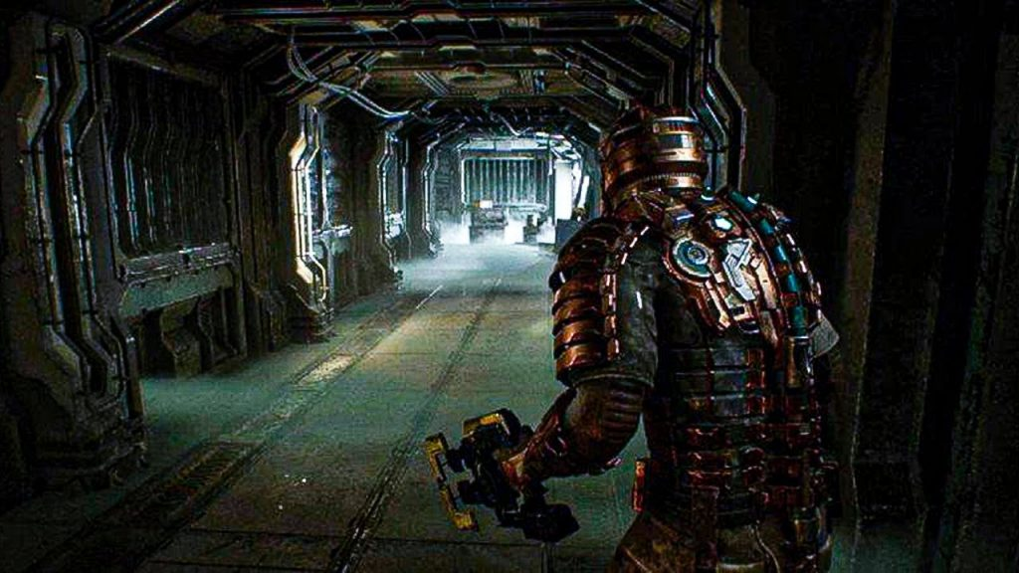dead space has the abandoned/damaged base setting.